# 软件版本

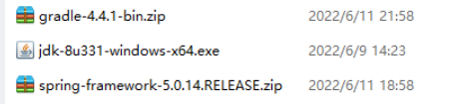

# 阿里云仓库

仓库官网

<https://developer.aliyun.com/mvn/guide>

build.gradle

#插件地址

maven { url "https://maven.aliyun.com/repository/spring-plugin" }

maven { url "https://maven.aliyun.com/repository/gradle-plugin" }

#仓库地址

maven { url "https://maven.aliyun.com/repository/spring" }

maven { url "https://maven.aliyun.com/repository/central" }

maven { url "https://maven.aliyun.com/repository/public" }

cmd进入spring-core所在目录，手动安装jar包

gradle objenesisRepackJar

gradle cglibRepackJar

执行编译命令

gradlew :spring-oxm:compileTestJava

# Spring-5

## build.gradle

spring-framework-5.0.14.RELEASE



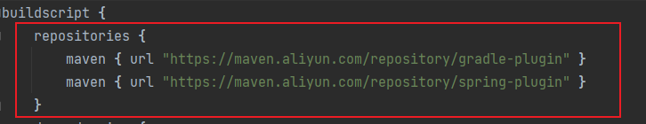

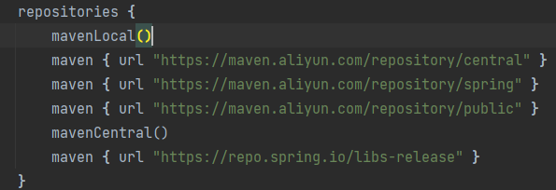

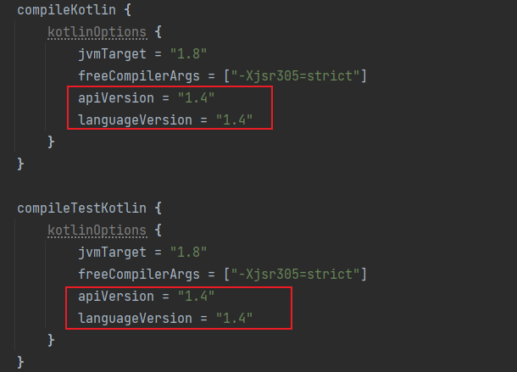

## gradle-wrapper.properties

spring-framework-5.0.14.RELEASE\gradle\wrapper



distributionUrl=file:///D:/myprogram/gradle-4.4.1-bin.zip

# Idea配置

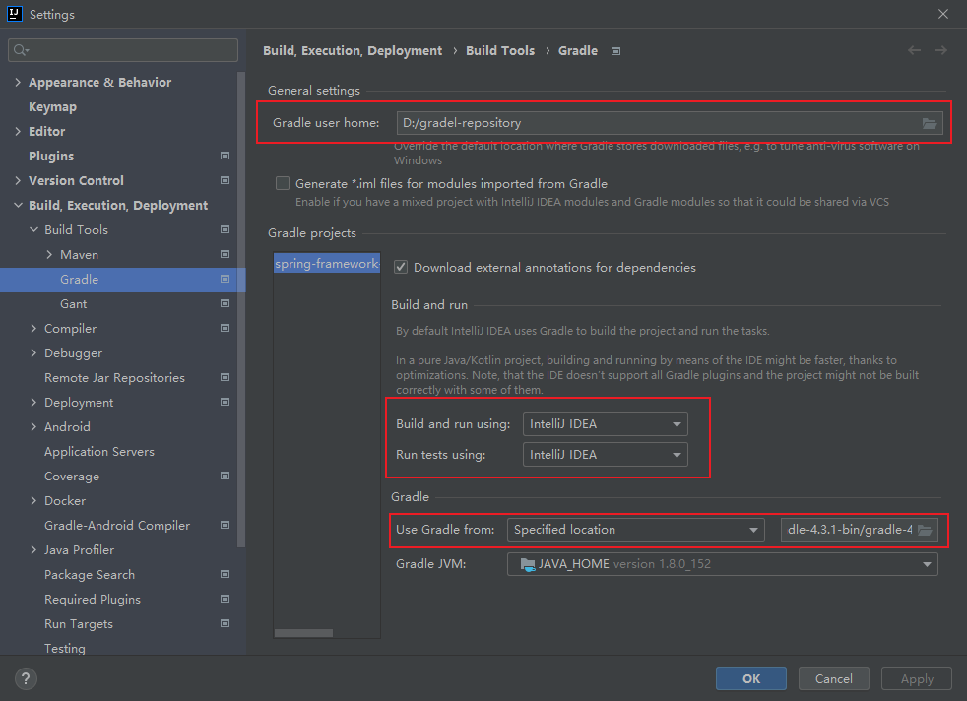

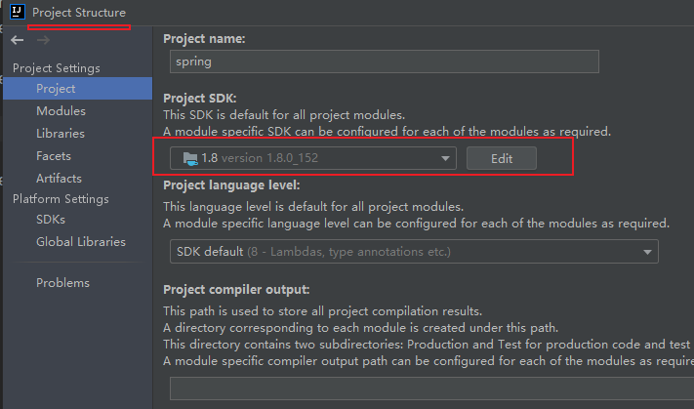

# 编译测试

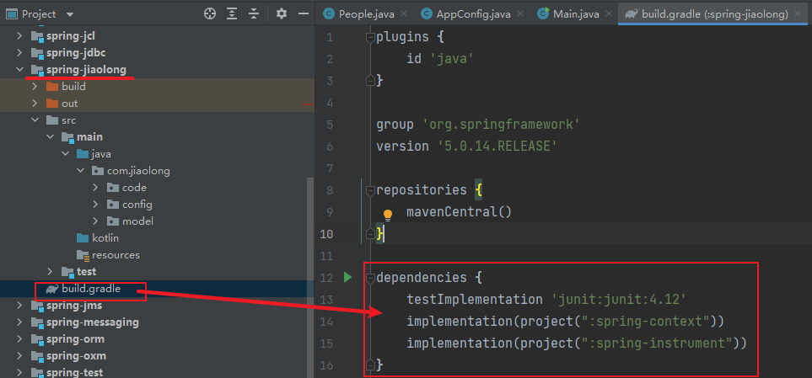 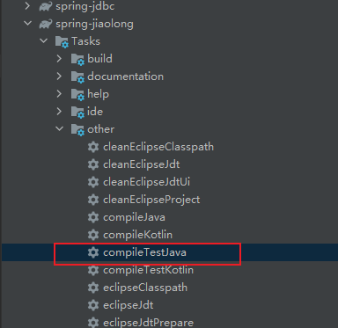

dependencies {

testImplementation 'junit:junit:4.12'

implementation(project(":spring-context"))

implementation(project(":spring-instrument"))

}



# 参考文章

[Spring 5.0.X源码编译](https://blog.csdn.net/wangyang00700/article/details/125240530)